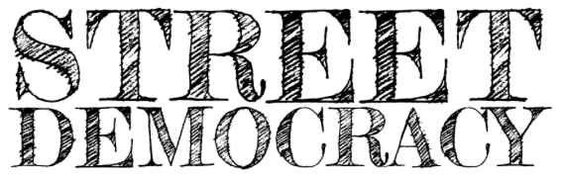

MEDIA RELEASE

Contact: Jayesh Patel
Date: June 23, 2017
Phone: (313) 355-4460
Email: jayesh@streetdemocracy.org

FOR IMMEDIATE RELEASE

Street Democracy to host Policy and Pie on July 25
Hands-on event offers opportunity to help shape advocacy efforts

Street Democracy will host its inaugural Policy and Pie, a public platform to learn about local and federal policies and proposals affecting homelessness and poverty, on Tuesday, July 25, 2017 from 6-8pm at TechTown, 440 Burroughs, Detroit, Michigan 48202.

Participants at this hands-on event will discuss and respond to local and federal proposed regulations and open for public comment. Participants will also learn about Street Democracy’s current policies under development and help determine content and priorities. Street Democracy attorneys and clients will share success stories and facilitate discussion on issues that community members would like to see addressed. Updates on progress will be provided at future events.

Street Democracy is a nonprofit legal services organization that provides holistic legal counsel to homeless individuals and military veterans in tight collaboration with local social service providers. The organization also leads several advocacy initiatives, including the Rehabilitative Sentencing Project, Court Watch, and school discipline reform advocacy.

“Policy and Pie gives those concerned with homelessness and poverty an opportunity to collectively shape our advocacy efforts and priorities moving forward,” says Jayesh Patel, the organization’s founder and director. “But more importantly, our community can take a moment to connect and celebrate progress… with pie.”

Policy and Pie is free and open to the public. Participants are encouraged to bring a laptop, smartphone, or other device that connects to the internet. A variety of pies will, indeed, be served. Visit http://bit.ly/2t6V4kl to register.

For more information on Street Democracy’s work, visit streetdemocracy.org.

###

Street Democracy, a 501(c)(3) legal services organization, provides counsel to homeless individuals and veterans to eliminate the legal barriers to their return to stability caused by the consequences of their past criminal histories.

