Capital and Blue Bikes Marketing Strategies
- Associated with Lyft- half their marketing gets done through that
- They have the scan system- that makes unlocking bikes a lot easier
  - Our kiosks should definitely have the help pamphlet that is on the app printed onto kiosks to help people find the keypad
  - The help icon in the app needs to be better coloured
- They have an own dedicated app that is more user friendly in the following ways
- One positive is that the websites of capital bikes and mogo are pretty similar
- Corporate and student discounts- plus a lot of perks for them
- Marketing idea: we should have events where you just drive MoGos down the riverwalk/belle isle -> best way most people know about MoGo is by seeing the bike itself,
- Study of 8 different bike shares in cities across the world is here: https://ralphbu.files.wordpress.com/2012/01/vt-bike-share-study-final3.pdf
- A lot of bike shares have different coloured bikes, more colorful so that they stand out more
- They organize tours of different places around the area
- All their new bikes have the ability to be locked on public bike stands- so if someone wants to stop and get something like while grocery shopping they don't need to worry about returning the mogo to a station and then going

Citi Bikes Marketing Strategies
- Their social media marketing is excellent-> have tik toks/reels, stuff that can go viral amongst a younger crowd
- They also have tourist guides for popular places around new york-> maybe something for Belle isle?

Bay Wheels Bikes Marketing Strategies

- Associated with Lyft
- QR Code
- Kiosks show the different passes
- Kiosk have a QR code for the Lyft App: Add QR Code to the Kiosk with the incentives
- Introducing Prepaid Cards
We’re committed to maintaining payment options for the unbanked and those who prefer to pay for Bike Share for All memberships with cash. To expand that offering, Bay Wheels now accepts prepaid cards as a payment option.
Prepaid cards can be bought at retail locations such as drug stores and grocery stores or online. No Social Security information is needed for the purchase of a prepaid card, and you can re-use the same prepaid card for all membership purchases or usage charges. Once a card is acquired, you can add it to your payment information in your account profile.
- Bike Angels: Crowded to Empty docks for rewards in the app
- Business Discount: Employees
- Partner with touring/travel agencies: MoGo Sightseeing Bike Tour 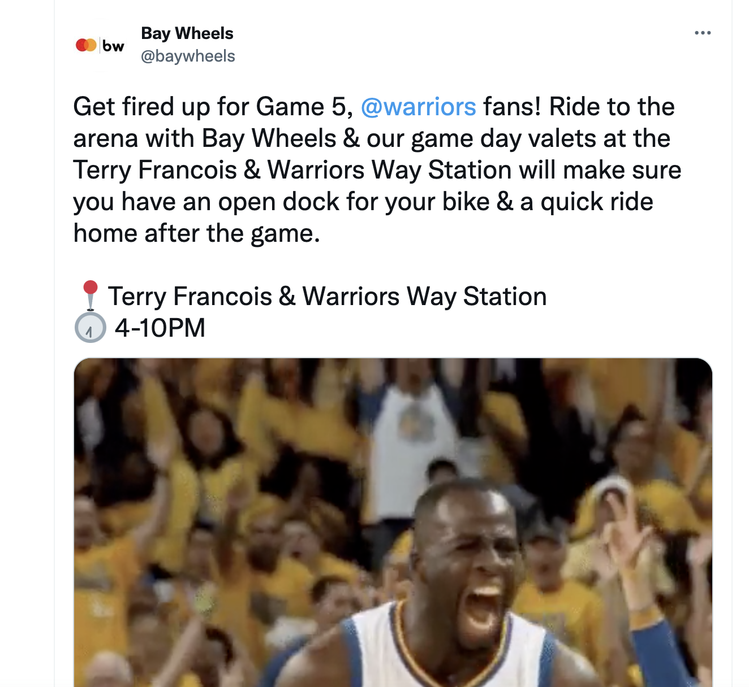
- 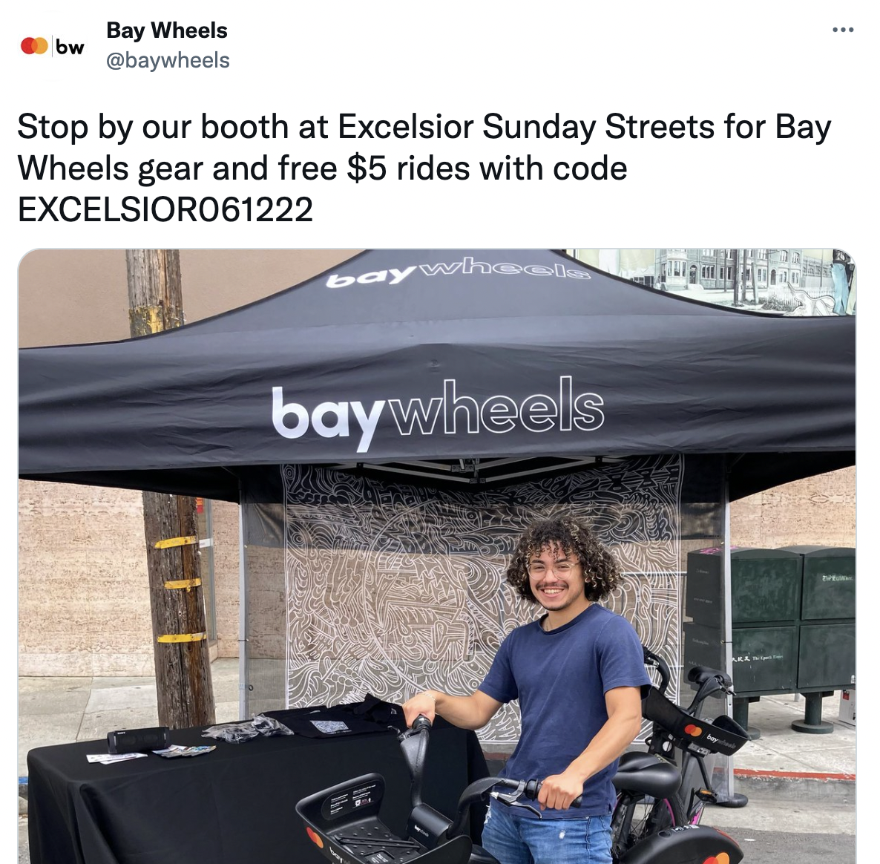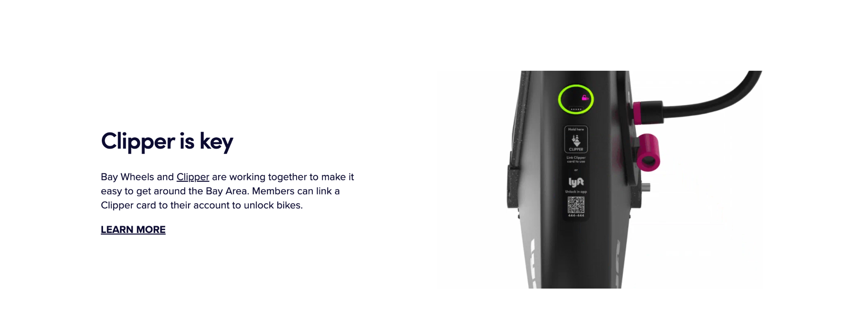
- Booths at the eastern market
- Detroit Tigers game day tickets/discounts for downloading the app
- Transit Equity Day

Nice Ride Bike Share:
- Bike to work day
- Detroit Bike Ride Guide
- World Bicycle Day
- 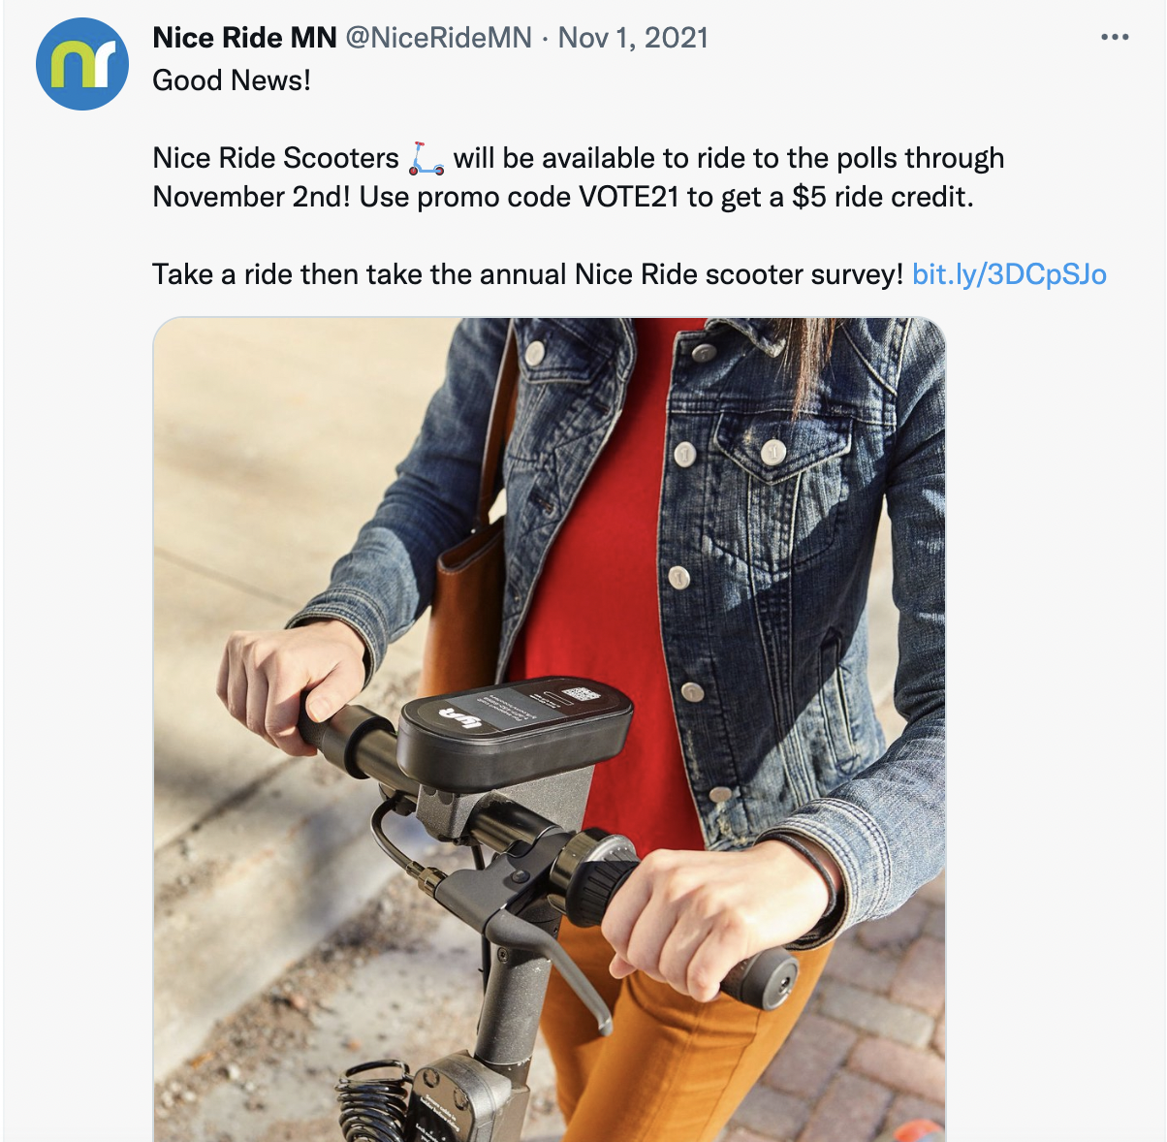
- Post on instagram with a bike – free discount code
- 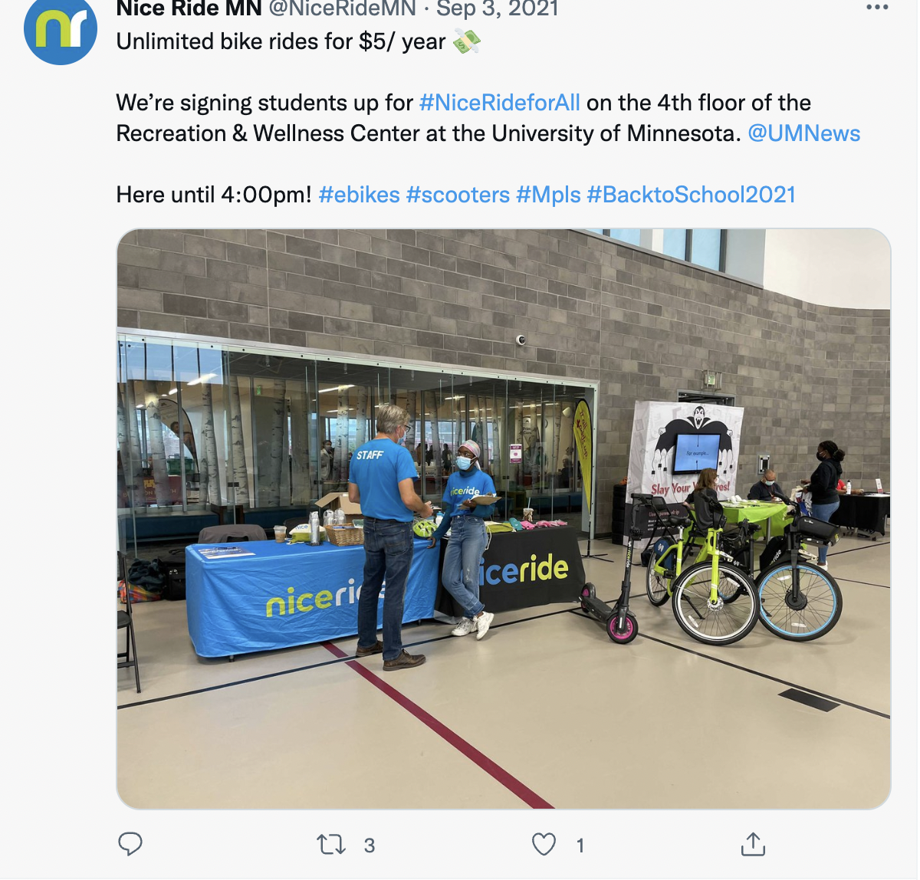

Structure: cover pages
Table of contents:
- Introduction
- Market Research
- Kiosk Changes
- Transit App Enhancement
- Social Media Ideas
- New Passes: Business and Students
- MoGo Community Events Ideas (World Bicycle Day, Cycle to Work, Booths, Rides, etc)
- Bike Angels
- GTM Strategy: Partnering with Tourist/Travel Agencies
- Detroit Bike Ride Guide
- RiderPerks
- Questions?

