FINANCIAL REPORT ON FUNCTINOAL SENTENCING

Street Democracy

40 Burroughs St #634, Detroit, MI 48202

(313) 355-4460

fb.com/streetdemocracy

Founded in 2011, Street Democracy is a team of attorneys and legal researchers working at the intersection of poverty and the law to reform the policies and systems that create and perpetuate poverty. Since then, over 400 Detroiters have benefited from their representation and been removed from poverty.

July 2019 | Arjun Bakshi

Purpose

The purpose of this report is:

To outline different interventions that can be used instead of traditional fines/incarceration that could result in reduced recidivism and greater societal benefits.

To investigate the immediate impact of implementing these alternative sentencing programs on the financial well-being of an individual, the economy and the government.

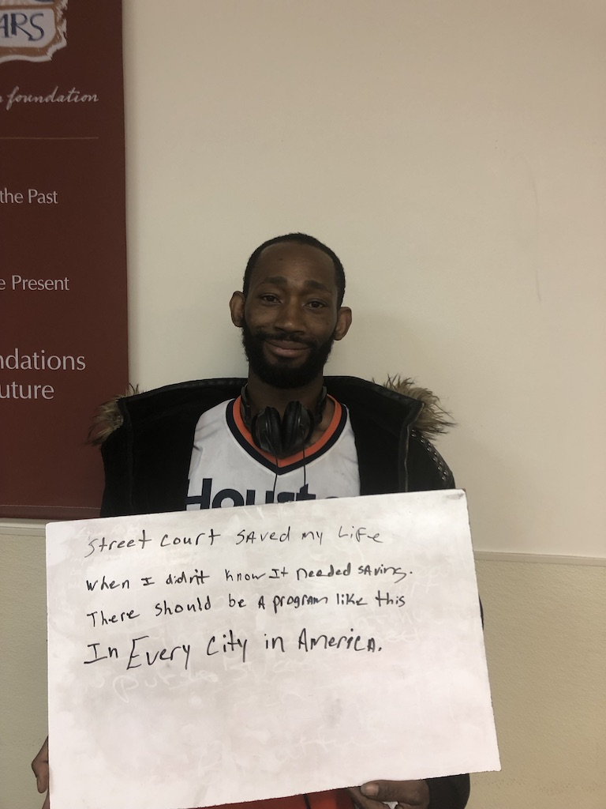
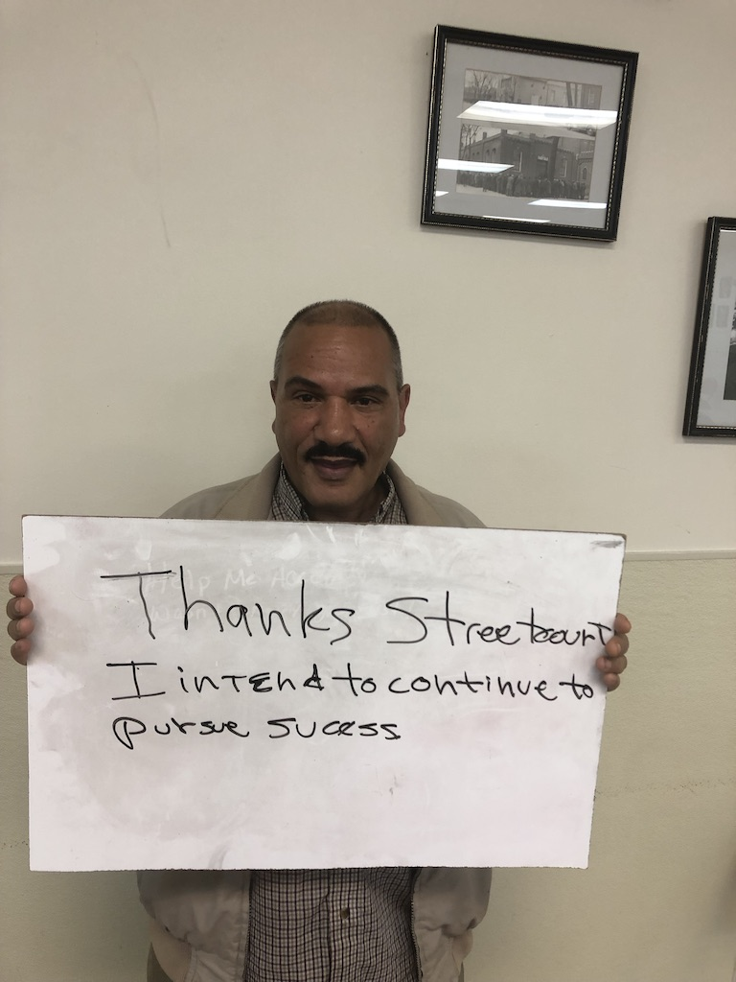
Functional Sentencing

Overview

The legal community is beginning to recognize that traditional misdemeanor criminal justice sentencing—a model characterized by punitive fines and incarceration—is counterproductive. The impact of incarceration on poverty and future criminal justice involvement is well documented. Incarceration, even for just one day, impairs individuals’ livelihoods, mental health, and future prospects and concomitantly sends ripple effects that threaten their families’ housing, mental health, and children’s performance in school. Money fines, when assessed without regard to ability to pay, have similar results, pushing the poor into deeper poverty and homelessness. The sustained economic hardship that results leads to poorer physical, psychological, and cognitive functioning, diminishing the very tools necessary to escape the cycle of poverty and punishment. Even survivors of violent crime overwhelmingly opt for alternative sentences, as they too recognize the ineffectiveness of punitive sentencing.
Punitive sentencing fails to achieve its goal of reduced recidivism because it relies on an outdated understanding of criminality and leaves unaddressed the underlying causes of their offending behavior. On the other hand, sentences that are clearly focused on rehabilitation (e.g. counseling, interpersonal skill development, cognitive-behavioral therapy) work well to reduce recidivism. Courts typically reserve these rehabilitative-type sentences for specialty courts or dockets. However, while courts in recent decades have implemented specialty courts with excellent results, these courts are prohibitively costly on a per person basis due to an intensive supervision model and focus only on a particular class of offenses or “worthy” defendants.
Functional Sentencing is a systematic sentencing regime that combines the public safety gains of specialty courts with the efficiency of traditional sentencing. It employs evidence-based practices from the behavioral sciences and social work to offer defendants’ interventions designed to both mitigate the root drivers of their criminogenic risk and enhance their personal, social, and socio-economic assets to resist criminal spin. By adopting a functional sentencing protocol, courts can achieve specialty court-level outcomes without any additional cost.

The Pilot

In 2017-2018, Street Democracy, a Michigan legal services nonprofit, partnered with Michigan’s 31st District Court to conduct a limited Functional Sentencing pilot program. Serving as house counsel at arraignment, we screened clients for indigency, performed a basic needs assessment, recommended a sentence based on those needs, and performed a follow-up interview three months post-sentencing. Based on survey and court data, we found that functional sentences produced better public safety and individual outcomes. With minimal additional expenditures and judicial oversight, recipients of functional sentences were more likely to improve their income and attain their driver’s license, and significantly less likely to experience housing instability or to re-offend. Anecdotally, defendants who received a functional sentence expressed a newfound trust in courts, “This was one of the few times I felt that the court not only treated me fairly, but actually cared about me.”

Action plan - Income

The action plans that have been used regarding income are the following:

42% rise in income from improved adult literacy
SSDI can increase income by up to $14,000

OVERVIEW OF INCOME ACTION PLAN

Income rises by $3900 1 year after completing a GED

Going to college increases a person’s income by $11,000 in the first-year post-graduation
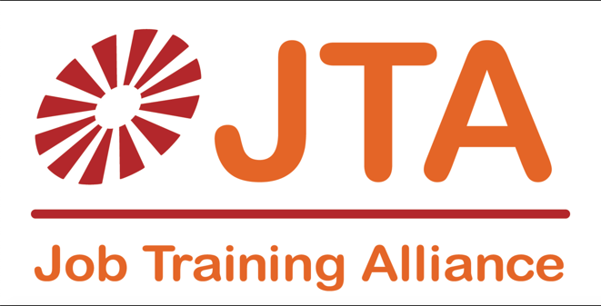
Raise income by 15%

Example action plan

Effect on an individual/family

Effect on community/economy

Effect on government

Sign up for adult literacy classes

Participants are shown to increase their income by $5,200.

The effect on the local economy will be $10,140 thanks to the multiplier effect.

Increase in government taxes by $973.

Sign up for GED classes

GED results in an increase in income by $3,928 compared to someone with no GED training.

The effect on the local economy will be $7,659 thanks to the multiplier effect

The government receives $735 more in income from each person taking a GED test

Apply for disability benefits

A person who receives disability benefits is expected to increase their income by $14,158 compared to someone not on benefits

The effect on the local economy will be $27,608 thanks to the multiplier effect

The government receives $2,650 more in income from each person

Enroll in a Job training program

Enrolling in a job training program increases income by $3,444 more than someone not in the program

The effect on the local economy will be $6715 thanks to the multiplier effect

The government receives $644 more in taxes each year

Enroll in college or vocational school

Going to college increases your wage by $10,381 in the 1 year post-graduation compared to someone who did not go to college

The effect on the local economy will be $20,242 thanks to the multiplier effect

Every student increases state tax revenue by $1,943.

Action plan - Housing

The action plans that have been used regarding housing are the following:

GED classes

OVERVIEW OF HOUSING ACTION PLAN

Affordable housing can contribute roughly $14,000 to the local economy through the multiplier
$1,700 saved by the government for every person who gets a housing subsidy

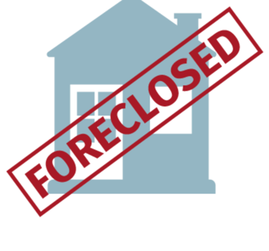
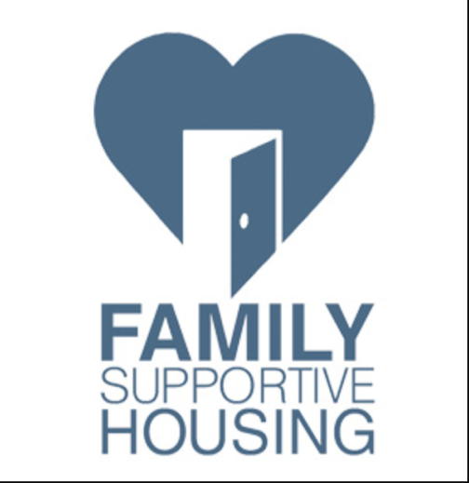
Supportive housing is expected to increase income by $3,590

Preventing foreclosure can save a family up to $12,000

Seek emergency shelter

A person in emergency shelter will receive $497.73 more than someone not in shelter in similar circumstances

The effect on the local economy will be $970 thanks to the multiplier effect

The government will increase their income by $93 for every person who gets emergency shelter

Apply for transitional/supportive housing

Transitional/supportive housing will increase income by $3,592 compared to someone not in that housing
The effect on the local economy will be $7,004 thanks to the multiplier effect

The government will receive $672 more in taxes

Apply for housing subsidy

A housing subsidy will increase income by $9,066 per year

The effect on the local economy will be $17,561 thanks to the multiplier effect

The government will receive $1,685 more per person from housing subsidy

Find new/affordable rental unit

Finding new/affordable rent can increase an individual’s income by $7,188 than what it was originally
The effect on the local economy will be $14,016 thanks to the multiplier effect

The government will receive $1,345 from new/affordable rent each year

Seek assistance with foreclosure issue

Seeking assistance with a foreclosure will save $12,098 for an individual each year

The effect on the local economy will be $23,591 thanks to the multiplier effect

The government will receive $2,264 from sustained property tax and government revenue

Action plan - Resources

The action plans that have been used regarding resources are the following:

- Obtain driver’s license

- Obtain photo ID/birth certificate/SS card

- Register to vote

- Sign up for lifeline telephone service

- Find and use a nearby food pantry

- Apply for food assistance

- Open up a bank account

- Sign up for financial literacy classes
$828 additional income gained from applying for food assistance

4X: A driver’s license could increase income by a factor of 4

OVERVIEW OF RESOURCES ACTION PLAN

One photo ID can generate $2000 in local spending in the economy
$1230 saved from taking financial literacy classes assistance

Obtain driver’s license

Having a driver’s license is able to increase employment a factor of 4

A driver’s license will contribute $4,538 to the economy every year

The government will receive $435 in additional taxes

Obtain photo ID/birth certificate/SS card

Having an ID will generate $1038 extra in income per year

The effect on the local economy will be $2,024 thanks to the multiplier effect
The government will receive $194 for each registered ID

Sign up for lifeline telephone service

COULD NOT FIND ANY STUDY WHICH SHOWED A CONCLUSIVE STUDY

The effect on the local economy will be $7,659 thanks to the multiplier effect

The government receives $735 more in tax for every smartphone

Find and use a nearby food pantry

Finding a food pantry can increase income by $105.8792 due to a food bank

The effect on the local economy will be $204 thanks to the multiplier effect

The government receives $19 more in income tax for every person who gets a job from food pantries

Apply for food assistance

Applying for food assistance increases an individual's income by $828.87
The effect on the local economy will be $1,616 thanks to the multiplier effect

The government will receive $155 more in taxes

Open up a bank account

Opening up a bank account will save $1,091 in a person’s income

The effect on the local economy will be $2,127 thanks to the multiplier effect

The government will receive $204 more in tax

Sign up for financial literacy classes

Financial literacy class will save $1,230 from improved knowledge. 34% lower delinquency rate

The effect on the local economy will be $2,398 thanks to the multiplier effect

The government will receive $230 more in tax

Action plan – Legal Action Plans at a glance

The action plans that have been used regarding resources are the following:

- Seek legal advice regarding child support issues

- Provide proof of compliance with parole or probation

$19,000 increase in spending in the economy if parole is granted

OVERVIEW OF LEGAL ACTION PLAN

$7500 potentially saved from seeking child support

Seek legal advice regarding child support issues

Seeking legal advice regarding child support issues could save $7500 in income per single-parent each year
The effect on the local economy will be $14,625 thanks to the multiplier effect.

The government will receive $1,404 more for each time a parent is trying to collect unpaid child support

Provide proof of compliance with parole or probation

Providing proof of compliance with parole/probation will increase income by a maximum expected value of $10,098

The effect on the local economy will be $19,691 thanks to the multiplier effect

The government could receive $1,890 more in taxes each year

According to the National Center for Education Statistics: Adult Literacy in America, a Level 1 reading level is the least literate people who did not complete high school, are often immigrants or have disabilities. They are expected to earn a maximum of $12,480/year (https://thevoiceofjobseekers.com/how-does-illiteracy-affect-job-seekers/.) Level 2 is a more advanced level that is expected to earn a minimum of $340/week or $ 17,680 each year. Therefore, the most conservative estimate is that people with improved adult literacy will make $5,200 more than people who have not had training.
According to the AARP Policy Institute, every $1 paid translates to $1.95 in spending. This will mean that the total economic output will be $10,140.
According to the National Conference for State Legislatures, 9.6% of GDP goes to local and state taxes. This means that the additional $10,140 will generate $973 in taxes. (http://www.ncsl.org/documents/fiscal/TaxesandtheEconomy.pdf)
Economic Benefits of the GED: Lessons from Recent Research: This study shows that average earnings are 17.5% higher for those with a GED compared to without one (10% higher for men, 25% higher for women). 1 person at a low income with no GED is projected to earn a maximum of $22,450 according to HUD (https://www.huduser.gov/portal/datasets/il/il17/State-Incomelimits-Report-FY17.pdf). There will be an increase in income of $3,928 due to a GED. (22,450*1.17 – 22450 = 3928).
According to the AARP Policy Institute, every $1 paid translates to $1.95 in spending. This will mean that the total economic output will be $7,659.
According to the National Conference for State Legislatures, 9.6% of GDP goes to local and state taxes. This means that the additional $7,659 will generate $735 in taxes. (http://www.ncsl.org/documents/fiscal/TaxesandtheEconomy.pdf)
$143 billion spent on SSDI payments in 2017 according to the Center on Budget and Policy Priorities. 11.1 million people are direct and indirect recipients of this. 143 billion / 11.1 million people is $14,158 per person.
According to the AARP Policy Institute, every $1 paid translates to $1.95 in spending. This will mean that the total economic output will be $27,608.
According to the National Conference for State Legislatures, 9.6% of GDP goes to local and state taxes. This means that the additional $27,608 will generate $2,650 in taxes. (http://www.ncsl.org/documents/fiscal/TaxesandtheEconomy.pdf)
1 person at a low income with no GED will earn a maximum of $22,450 according to HUD (https://www.huduser.gov/portal/datasets/il/il17/State-Incomelimits-Report-FY17.pdf). The maximum unemployment benefits 1 person can receive in Michigan is $362/week (https://www.nolo.com/legal-encyclopedia/collecting-unemployment-benefits-michigan.html). This totals $18,824 per year. The rise in income is $3626. The employment rate for high school graduates with no college experience is 95% according to the 2017Y survey collected by the Bureau of Labor Statistics. Therefore, the expected value of the increase in income is 3626*95%, which totals to $3,444.
According to the AARP Policy Institute, every $1 paid translates to $1.95 in spending. This will mean that the total economic output will be $6715.
According to the National Conference for State Legislatures, 9.6% of GDP goes to local and state taxes. This means that the additional $6,715 will generate $644 in taxes. (http://www.ncsl.org/documents/fiscal/TaxesandtheEconomy.pdf)
The average wage for a regularly labor worker is $11.12/hour. This equates to $22,240 per year (11.12*40*50). The average wage for a skilled worker who went through vocational school is $34,900 according to the National Center for Education Studies. This is a difference of $12,660. The graduation rate for vocational schools is 82%. (https://pioneerinstitute.org/blog/blog-education/blog-school-schoice/the-incredible-shrinking-voc-tech-dropout-rate/) Therefore the expected increase in salary is 12660*82% = $10,381.
According to the AARP Policy Institute, every $1 paid translates to $1.95 in spending. This will mean that the total economic output will be $20,242.
According to the National Conference for State Legislatures, 9.6% of GDP goes to local and state taxes. This means that the additional $22,430 will generate $1,943 in taxes. (http://www.ncsl.org/documents/fiscal/TaxesandtheEconomy.pdf)
Wage*homeless rate of people with a job + wage*homeless people without a job. $12,965 (https://nlihc.org/resource/employment-and-earnings-among-nyc-homeless-adults) *21% (https://parade.com/643064/beckyhughes/working-homeless-population-grows-in-cities-across-the-u-s/) = 2722.65. $13,531 (https://nlihc.org/resource/employment-and-earnings-among-nyc-homeless-adults) *23.8% (60k*70*34%/60k - https://parade.com/643064/beckyhughes/working-homeless-population-grows-in-cities-across-the-u-s/) = 3,220.378. Rise in income by $497
According to the AARP Policy Institute, every $1 paid translates to $1.95 in spending. This will mean that the total economic output will be $970.
According to the National Conference for State Legislatures, 9.6% of GDP goes to local and state taxes. This means that the additional $970 will generate $93 in taxes. (http://www.ncsl.org/documents/fiscal/TaxesandtheEconomy.pdf)
A review of Jobs-Plus found that where program components were fully implemented, the program produced a 16 percent increase in average annual earnings. (https://howhousingmatters.org/articles/families-will-benefit-expanding-evidence-base-supportive-housing/) 1 person at a low income is projected to earn a maximum of $22,450 according to HUD (https://www.huduser.gov/portal/datasets/il/il17/State-Incomelimits-Report-FY17.pdf). A 16% rise in income will lead to an income of $26,042. The increase in income as a result of transitional/supportive housing will be $3,952.
According to the AARP Policy Institute, every $1 paid translates to $1.95 in spending. This will mean that the total economic output will be $7,004.
According to the National Conference for State Legislatures, 9.6% of GDP goes to local and state taxes. This means that the additional $7004 will generate $672 in taxes. (http://www.ncsl.org/documents/fiscal/TaxesandtheEconomy.pdf)
According to a study conducted by the Journal of Policy Analysis and Management, a housing subsidy provides a net economic benefit of $9,066 which includes public benefits, child benefits, improved health and decreased crime. (The Benefits and Costs of the Section 8 Housing Subsidy Program: A Framework et Estimates of First-Year Effects – pg 235)
According to the AARP Policy Institute, every $1 paid translates to $1.95 in spending. This will mean that the total economic output will be $17,561.
According to the National Conference for State Legislatures, 9.6% of GDP goes to local and state taxes. This means that the additional $17,561 will generate $1,685 in taxes. (http://www.ncsl.org/documents/fiscal/TaxesandtheEconomy.pdf)
100 affordable rental units create 152 jobs directly and indirectly according to a report titled “The Role of Affordable Housing in Creating Jobs and Stimulating Local Economic Development.” (page 3) There is an average of 2.55 people in each Michigan household from the 2000 Census. This means that 255 people contribute to 152 jobs. Scaled down, 1 person creates 0.596 jobs. If the poverty level for an individual in the United States is $12,060 (https://www.vox.com/2019/6/5/18650437/usda-snap-food-stamps-economic-impact), then each person will now experience an income of 12060*1.596. This totals to $19,248, which is a $7,188 rise in income.
According to the AARP Policy Institute, every $1 paid translates to $1.95 in spending. This will mean that the total economic output will be $14,016.
According to the National Conference for State Legislatures, 9.6% of GDP goes to local and state taxes. This means that the additional $14,016 will generate $1,345 in taxes. (http://www.ncsl.org/documents/fiscal/TaxesandtheEconomy.pdf)
In the mid-1990s, the Family Housing Fund in Minneapolis estimated the average family lost $7,200 through foreclosure. (https://www.urban.org/sites/default/files/publication/30426/411909-The-Impacts-of-Foreclosures-on-Families-and-Communities.PDF) When taking into account inflation, this makes the cost $12,098 to a family.
According to the AARP Policy Institute, every $1 paid translates to $1.95 in spending. This will mean that the total economic output will be $23,591.
According to the National Conference for State Legislatures, 9.6% of GDP goes to local and state taxes. This means that the additional $23,591 will generate $2,264 in taxes. (http://www.ncsl.org/documents/fiscal/TaxesandtheEconomy.pdf)
Urban Institute released a report titled “Understanding the Links among Transportation Access, Residential Outcomes, and Economic Opportunity for Housing Voucher Recipients.” On page 50 it states that having a car can increase the chance of being employed by a factor of four.
The auto industry contributes $953 billion to the economy each year, indirectly and directly (https://autoalliance.org/economy/). There are 210 million licenses in the US according to a 2009 Study conducted by the Federal Highway Administration. This means that each license contributes $4,538 to the economy each year
According to the National Conference for State Legislatures, 9.6% of GDP goes to local and state taxes. This means that the additional $4,538 will generate $435 in taxes. (http://www.ncsl.org/documents/fiscal/TaxesandtheEconomy.pdf)
Photo ID or having a birth certificate prevents identity fraud from taking place. Approximately 15.4 million Americans were the victims of identity fraud in 2016, with losses totaling $16 billion (https://www.usatoday.com/story/money/personalfinance/2017/02/06/identity-theft-hit-all-time-high-2016/97398548/). This totals to $1038 per person being saved.
According to the AARP Policy Institute, every $1 paid translates to $1.95 in spending. This will mean that the total economic output will be $2,024.
According to the National Conference for State Legislatures, 9.6% of GDP goes to local and state taxes. This means that the additional $2,024 will generate $194 in taxes. (http://www.ncsl.org/documents/fiscal/TaxesandtheEconomy.pdf)
According to the AARP Policy Institute, every $1 paid translates to $1.95 in spending. This will mean that the total economic output will be $7,659.
According to the National Conference for State Legislatures, 9.6% of GDP goes to local and state taxes. This means that the additional $7,659 will generate $735 in taxes. (http://www.ncsl.org/documents/fiscal/TaxesandtheEconomy.pdf)
1.1 million permanent jobs in the United States are generated directly and indirectly through food banks. (https://www.perrymangroup.com/publications/column/2014/12/29/economic-benefits-of-the-food-bank-and-charitable-food-distribution-network/) There are 60,000 food pantries in America (https://www.feedingamerica.org/our-work/food-bank-network). This equates to 18 jobs created from each food pantry. 37 million Americans use food pantries each year according to a study called “Feeding South Dakota. Feeding America Food Bank Network.” This means that an average of 616 people utilize one food pantry. 1 person at a low income with no GED is projected to earn a maximum of $22,450 according to HUD (https://www.huduser.gotv/portal/datasets/il/il17/State-Incomelimits-Report-FY17.pdf). The maximum one person can earn from unemployment benefits is $18,824 ((https://www.nolo.com/legal-encyclopedia/collecting-unemployment-benefits-michigan.html). The difference in income is $3626. Since only 18 out of 616 people who use a food pantry find a job, the expected increase in income is 3626*18/616. This total to an average income in income of $105.88 due to a food bank,
According to the AARP Policy Institute, every $1 paid translates to $1.95 in spending. This will mean that the total economic output will be $204.
According to the National Conference for State Legislatures, 9.6% of GDP goes to local and state taxes. This means that the additional $204 will generate $19 in taxes. (http://www.ncsl.org/documents/fiscal/TaxesandtheEconomy.pdf)
For every $22,000 spent on food stamps, 1 job is created. (https://www.vox.com/2019/6/5/18650437/usda-snap-food-stamps-economic-impact) The average amount of food assistance one person receives each year is $1512 (126*12) according to the Center on Budget and Policy Priorities. (https://www.cbpp.org/research/food-assistance/chart-book-snap-helps-struggling-families-put-food-on-the-table) 22,000/1512 means it takes 14.55 people to create 1 job through food assistance. This means that each person receiving food assistance create 0.0687 jobs. 1 person at 30% of the median income in Michigan is expected to earn $13450/year according to HUD. (https://www.huduser.gov/portal/datasets/il/il17/State-Incomelimits-Report-FY17.pdf) 13450*1.06872852234 = 14,374. The difference in income is $924. Therefore, applying for food assistance will increase an individual’s income by $924.
According to the AARP Policy Institute, every $1 paid translates to $1.95 in spending. This will mean that the total economic output will be $1,616.
According to the National Conference for State Legislatures, 9.6% of GDP goes to local and state taxes. This means that the additional $1,616 will generate $155 in taxes. (http://www.ncsl.org/documents/fiscal/TaxesandtheEconomy.pdf)
The average person takes out $375 in payday loans. (https://lendedu.com/blog/payday-loan-statistics/) The average interest on payday loans is 391% (https://www.frbatlanta.org/economy-matters/community-and-economic-development/2018/10/16/lack-of-access-to-financial-services-impedes-economic-mobility#main). The difference between 1,466.25 (371*391%) and 375 is $1,091.
According to the AARP Policy Institute, every $1 paid translates to $1.95 in spending. This will mean that the total economic output will be $10,140.
According to the National Conference for State Legislatures, 9.6% of GDP goes to local and state taxes. This means that the additional $2,127 will generate $204in taxes. (http://www.ncsl.org/documents/fiscal/TaxesandtheEconomy.pdf)
It is found that the average person lost $1,230 due to a lack of financial knowledge in 2018. (https://www.financialeducatorscouncil.org/financial-illiteracy-costs/) As well as this, a study was conducted titled “Social and economic benefits of improved adult literacy: Towards a better understanding” which found that those who received individual counselling had a 34% lower delinquency rate than those who had not.
According to the AARP Policy Institute, every $1 paid translates to $1.95 in spending. This will mean that the total economic output will be $2,398.
According to the National Conference for State Legislatures, 9.6% of GDP goes to local and state taxes. This means that the additional $2,398 will generate $230 in taxes. (http://www.ncsl.org/documents/fiscal/TaxesandtheEconomy.pdf)
The average monthly child support payments are $625 per month. (https://family-law.freeadvice.com/family-law/child_support/amount_child_support.htm) 625*12 = $7500.
According to the AARP Policy Institute, every $1 paid translates to $1.95 in spending. This will mean that the total economic output will be $14,625.
According to the National Conference for State Legislatures, 9.6% of GDP goes to local and state taxes. This means that the additional $14,625 will generate $1,404 in taxes. (http://www.ncsl.org/documents/fiscal/TaxesandtheEconomy.pdf)
By providing proof of compliance, an ex-convict can then apply for jobs and seek employment. 72,7% of them find employment. (https://www.prisonpolicy.org/reports/outofwork.html) The average reported income is $13,890 according to an economic study conducted at Brookings Institute (https://www.brookings.edu/wp-content/uploads/2018/03/es_20180314_looneyincarceration_final.pdf). Therefore, the expected income is $10,098 (13890*72,7%).
According to the AARP Policy Institute, every $1 paid translates to $1.95 in spending. This will mean that the total economic output will be $19.961.
According to the National Conference for State Legislatures, 9.6% of GDP goes to local and state taxes. This means that the additional $19,961 will generate $1,890 in taxes. (http://www.ncsl.org/documents/fiscal/TaxesandtheEconomy.pdf)

